**Energy systems**

1. The food we eat is digested into:  
   (a) glucose, free fatty acids and amino acids  
   (b) glucose, glycogen and fats  
   (c) creatine phosphate, minerals and glycogen  
   (d) triglycerides, protein and carbohydrates
2. Adenosine triphosphate  
   (a) occurs in the muscle cells in only small amounts  
   (b) is the immediate source of energy for the muscle cells  
   (c) releases energy when it breaks down to ADP and phosphate  
   (d) all of the above

3) The anaerobic energy system is made up of the following:

(a) ADP - CP

(b) ATP - CP

(c) Anaerobic glycolysis

(d) ATP – CP and Lactic acid

4) The amount of ATP stored by the body is limited. The amount is between:  
 (a) 40 – 59 grams in total   
 (b) 60 – 79 grams in total  
 (c) 80 – 100 grams in total  
 (d) 101 – 120 grams in total

5) Twenty seconds into an athletic event such as the 200 metre sprint, two

energy systems are contributing approximately the same. They are the:

(a) ATP-CP and Aerobic systems  
 (b) ATP-CP and Lactic Acid systems  
 (c) Lactic Acid and Aerobic systems  
 (d) CP and Lactic acid systems

6) ATP is a relatively heavy molecule. If not rebonded it is estimated that every day we use an amount of ATP equivalent to what percentage of our bodies:

(a) 55%  
(b) 65%  
(c) 75%

(d) 85%

7) When switching from glycogen to free fatty acids as the major fuel source in a marathon, the performer must slow down because

(a) more oxygen is required to resynthesise ATP and less is available to working muscles  
(b) more processes are required in breaking down free fatty acids and hence ATP is resynthesised at a slower rate  
(c) it is likely that the performance will increasingly start to become anaerobic  
(d) all of the above

8) The ATP-CP system provides energy mostly at the start of an explosive activity because

(a) it is impossible to release ATP using the aerobic system in such a short period of time  
(b) it requires the least number of chemical reactions to break down CP and resynthesise ATP  
(c) it is readily available at the muscle site  
(d) all of the above

9) Thirty eight molecules of ATP can be produced for each molecule of glucose. Which energy system are we referring to?

(a) the lactic acid system  
(b) the ATP-CP energy system  
(c) the aerobic energy system  
(d) the creatine phosphate system

10) Glycogen results from the combination of a large number of:

* 1. carbohydrates
  2. glucose molecules
  3. sucrose molecules
  4. low GI foods

11) Adenosine triphosphate is comprised of:

1. one adenosine molecule and two phosphate ions
2. one adenosine molecule and three inorganic ions
3. one adenosine and three phosphate ions
4. one adenosine molecule, fats and glycogen

12) Human physical activity can only be fuelled by one specific energy source which is called:

1. adenosine triphosphate
2. glucose
3. adenosine diphosphate
4. carbohydrates

13) The energy used by a runner to complete a 100 m sprint is predominantly provided by the:

1. energy stored in the liver
2. lactic acid system
3. muscles stores of ATP
4. ATP - CP system

14) In completing their 5000m event a runner obtains energy for their muscles:

1. from contribution by the aerobic energy system only
2. from contribution by the anaerobic energy system only
3. from an even contribution by the aerobic and anaerobic pathways
4. primarily from the aerobic energy system with some contribution from their anaerobic energy systems

15) The primary food fuel for energy production during high intensity physical activity would be:

1. CP
2. glucose
3. fats
4. carbohydrates

16) To produce energy during an ultra - marathon top level athletes:

1. uses only carbohydrate
2. uses carbohydrates and fats
3. only uses fats
4. uses fats, carbohydrates and a small proportion of proteins

17) We store enough ATP/CP to power about how many seconds of intense activity:

1. 2 seconds
2. 5 seconds
3. 8 seconds
4. 10 seconds

18) Lactic acid is removed during recovery from exercise by:

1. the anaerobic system
2. anaerobic glycolysis
3. the ATP – CP system
4. the aerobic system

19) Fats we consume are broken down in the digestive system to:

a) saturated fats

b) free fatty acids

c) triglycerides

d) unsaturated fats

20) The end product produced by anaerobic glycolysis is:

a) pyruvate

b) co2

c) h2o

d) lactic acid

**Section 2: Short Answer Marks 60**

**Write your answers in the space provided.**

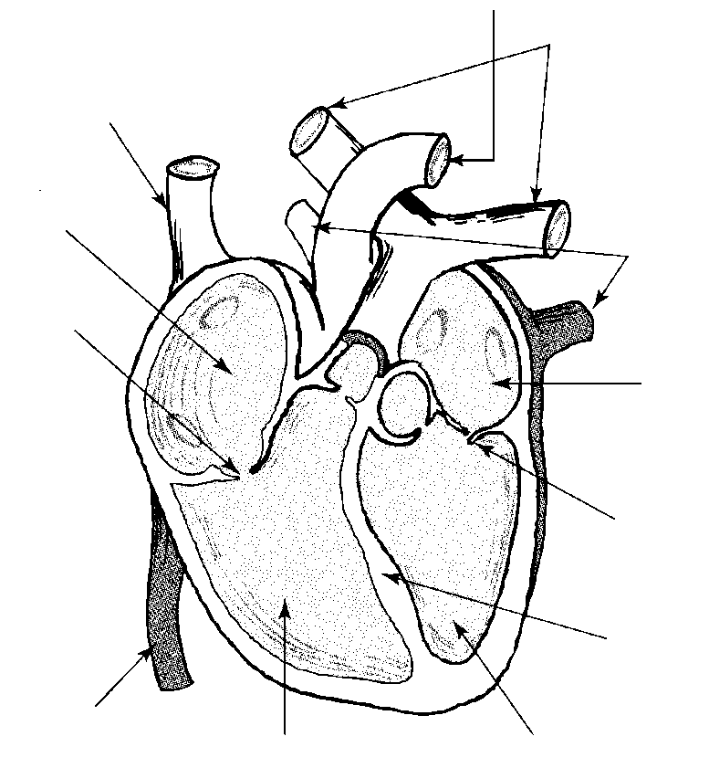1. Describe the **three things that determine which is the predominant energy system in any given physical activity?**

………………………………………………………………………………………….

………………………………………………………………………………………….

………………………………………………………………………………………….

………………………………………………………………………………………….

…..

………………………………………………………………………………………….

…………………………………………………………………………………………

(6 marks)

2) Under resting conditions:

(a) Which energy system produces the most ATP molecules?

(1 mark)

(b) What is the above system major fuel source?

.………………………………………………………………………………………

(1 mark)

3) Fill in the following table:

|  |  |  |  |  |
| --- | --- | --- | --- | --- |
| Energy Systems | Limitations/  Cause of  fatigue | Oxygen  Required? | Fuel  source | Speed of Energy Production |
| ATP/CP |  |  |  |  |
| Anaerobic Glycolysis |  |  |  |  |
| Aerobic  Glycolysis |  |  |  |  |

(6 marks)

4. Define what oxygen deficit is? Briefly discuss the system(s) that are utilised in this phase.

………………………

………………………………………………………………………………………….

.

…………………………………………………………………………………………

………………………………………………………………………………………….

…………………………………………………………………………………………

…………………………………………………………………………………………

………………………………………………………………………………………….

…………………………………………………………………………………………

(3 marks)

5. 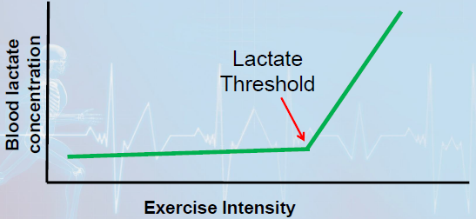

Use the graph above to explain what has and is occurring. Include a reason why?

………………………………………………………………………………………….

………………………………………………………………………………………….

(3 marks)

6. 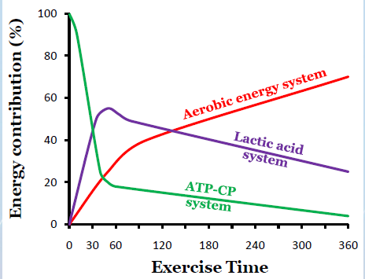

**In Seconds**

Use the graph above to explain how the energy systems work together?

…………………………………………………………………………………………

………………………………………………………………………………………..

(3 marks)

7. Briefly explain how CP stores are replenished during recovery from exercise when adequate oxygen is available?

…………………………………………………………………………………………

…………………………………………………………………………………………

…………………………………………………………………………………………

………………………………………………………………………………………….

…………………………………………………………………………………………

(2 marks)

8. Give two examples of activities that each of the energy systems are used for. i. ATP/CP A. …………………………………………

B. …………………………………………

ii. Lactic Acid A. …………………………………………

B. …………………………………………

iii. Aerobic System A. …………………………………………

B. ………………………………………….

(3 Marks)

9.(a) Name the location within the cell that ATP production occurs at?

(1 mark)

(b) Explain what the term “steady state oxygen consumption” means?

…………………………………………………………………………………………

…………………………………………………………………………………………

………………………………………………………………………………………..

…………………………………………………………………………………………

(3 marks)

10. Place the following activities on the appropriate energy continuum space using the letters A – F.

a. shot put b. 1500 m c. 400m

d. marathon e. 100m f. 10,000m

Aerobic Anaerobic

(3 marks)

11. a) If the athlete participating in the long distance running was of average fitness and completed the run at 80% HR max, which fuel would be the largest contributor in oxidation? Explain

…………………………………………………………………………………………

…………………………………………………………………………………………

………………………………………………………………………………………..

………………………………………………………………………………………..

……………………………………………………………………………………….

(2 Marks)

(b) Which other fuel would contribute during a long distance run?

(1 mark)

c) Explain how using a higher percentage of this fuel could benefit the endurance athlete?

………………………………………………………………………………………..

……………………………………………………………………………………….

………………………………………………………………………………………

( 2 Marks)

12 (a) Low Glycemic Index (GI) foods contain carbohydrates that are more slowly digested and absorbed than high GI foods, creating a slower, steadier blood glucose level.

Why is it best for athletes to consume low GI foods prior to any team sports that may last up to approximately 90 minutes?

(2 marks)

(b) List below 2 types of high GI foods and 2 types of low GI foods?

(2 marks)

(c)

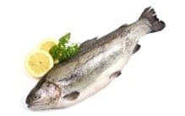 

Name the type of food above. What percentage should it contribute to our dietary intake?

………………………………………………………………………………………….

(1 Mark)

(d) 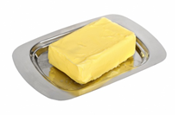 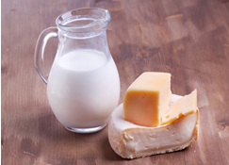

Name the type of food above? They should contribute approximately what percentage of our daily intake? Name the 2 types and the differences between them?

…………………………………………………………………………………………

…….………………………………………………………………………………….

…………………………………………………………………………………………

(3 marks)

(e) 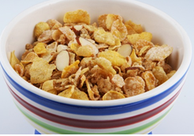 

Name the food type shown above in the diagram? What percentage should they contribute to our daily intake? What is the difference between the two types of this food?

…………………………………………………………………………………………

………………………………………………………………………………………….

…………………………………………………………………………………………

(3 marks)

13) Once carbohydrates is converted to another substance. Name that substance and explain the two important roles it has?

………………………………………………………………………………………….

………………………………………………………………………………………….

………………………………………………………………………………………….

(4 marks)

14. The term “hitting the wall” used by marathon runners. Explain the term and what has occurred. Include the reasons why?

………………….

………………………………………………………………………………………….

………………………………………………………………………………………….

………………………………………………………………………………………….

……………………………………………………………………………………………………….

………………………………………………………………………………………………………..

……………………………………………………………………………………………………….

……………………………………………………………………………………………………….

………………………………………………………………………………………………………

………………………………………………………………………………………………………

(4 marks)

15) What is the body’s preferred food fuel? Give a reason why?

………………………………………………………………………………………

………………………………………………………………………………………

………………………………………………………………………………………

(2 Marks)